EDM profile for Sounds
Collection of use cases

The Task Force on EDM profile for Sounds aims at creating an EDM profile for describing sounds materials. The first step in the process is the collection of use cases. These cases will allow the Task Force to scope its activities and define clear requirements that will form the basis of the EDM profile for Sounds.

The current fields for the use case templates are:

1) Title of the use case(s)

Historical collections of sound documents of the Central Institute for sound and audiovisual heritage

2) Owner's case name and name of the represented institution

Central Institute for sound and audiovisual heritage (ICBSA)

Use case(s):
3) Provide a general description of your use case(s). You can also add to your use case(s) images, diagrams if needed.
A use should contain information on:
-what is the type of sound objects you provide Europeana (vinyle, recording, music sheet….)
-Are these objects composed of different elements? If yes, what is the type of the relationship between an object and its different components or between the components themselves?
-Do the objects have digital representations? And if yes, of what type (same recording in different formats, video, images…)?

Example from the report of the Task Force on Hierarchical Objects http://pro.europeana.eu/web/network/europeana-tech/-/wiki/Main/Taskforce+on+hierarchical+objects written by Rodolphe Bailly, Cité de la Musique.
At the Cité de la musique, a concert recording is documented as a hierarchy of records.
The first, top level record describes the "concert". It contains general information about the recording of the concert itself, such as title, date, location and the most important performers and composers. The other records describe the "constituents" of the concert, i.e. the musical works performed during the concert. Each of these constituent, situated at a lower level of the hierarchy, contains detailed information about the performed musical works (for instance the complete list of performers). If needed, each of the performed musical work record may also have constituent records, such as specific parts in a symphony.
This concert recording can be represented as follow:
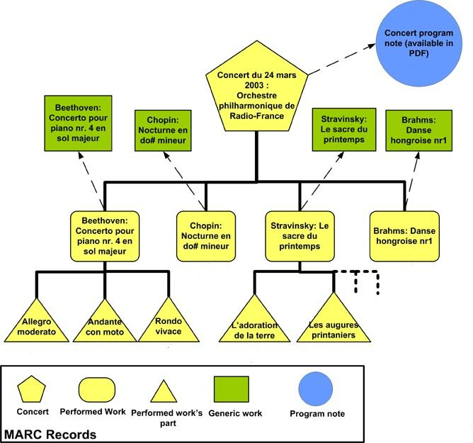

Digitized Historical sound recordings from 78rpm and cylinders collections; Sound recordings from 33rpm collection and CDs collection (classical music, pop music, folk music, traditional, literature, oral history).
The collections include digital representations as sound files and in several case also image files representing scanned accompanying material.
The sound files are in broadcast wave format 48khz or 96 khz 24 bit (are also available browsing copies in mp3 256 Kbit/s or 32 Kbit/s ), image files are jpeg 300 dpi 24 bit and web version copies jpeg 150 dpi.
All the collections contains records documented as a hierarchy in two level. The first level contains general information about the recording (Monographic level). The second level describes each single component part (Analytic level).

Data sample illustrating the use case
4) Each use case should be illustrated by (a) data sample(s).
Upload your data sample(s) at https://drive.google.com/folderview?id=0B4N3jJ2PToabWU1scDVFZGVKVEU&usp=sharing and indicate the name of the file(s) in this questionnaire for reference.

Use Case Template:
EDMSounds_UseCaseTemplate_ICCU.doc

Data samples:
Mag_IT-DDS0000086978000000_ICCU.xml
Mag_IT-DDS0000086978000100_ICCU.xml
Mag_IT-DDS0000086978000200_ICCU.xml

5) What metadata format is used in the samples(s)?

MAG 2.0.1 version

6) Describe how you use this metadata format to support the described use case(s) (can include details on specific metadata elements, data quality aspects…)

The MAG schema is a national standard for encoding descriptive, administrative, and structural metadata regarding objects within a digital library, expressed using the XML schema language of the W3C.
It is an application profile and consist of data elements drawn from more namespaces: DC, NISO, XLINK and MAG.

The root element is <mag:metadigit>

Regarding shown use-case, the main sections are:

GEN section <mag:gen>
It provides general information about the digitalization project.
It’s mandatory and not repeatable

BIB section <mag:bib>
It provides descriptive metadata about the analogical object.
In this section there are DC (unqualified) and MAG elements
It’s mandatory and not repeatable

IMG section <mag:img>
It collects the metadata relating to an image with all its eventual resolution versions.
It is usually optional but for this use-case is well-recommended in monographic records.
It’s repeatable: one section for each image and all its resolution versions

AUDIO section <mag:audio>
It mainly describes the technical data about a file containing an audio track.
For example, it describes track’s duration or bitrate.
For audio files, it’s mandatory.
It’s repeatable: one section for each track

The records have hierarchy, there are two bibliographic levels:
Monographic level (<mag:bib level="m">)
Analytic level (<mag:bib level="a">)

For more information about MAG schema, see also:

http://www.internetculturale.it/opencms/export/sites/ntc/documenti/pagine/Reference_Schema_MAG_2.0.1_-_traduzione_inglese_con_aggiornamenti_per_gli_archivi.pdf

http://www.iccu.sbn.it/opencms/opencms/documenti/mag2-2006.html

Vocabularies
7) Are you using specific vocabularies(e.g. thesauri) to describe information such as subjects, genres in your metadata?
If not go to question 11.

We don’t use specific vocabularies to describe information about subjects and genres.
We use some music coded data UNIMARC format (field 126) relating to the physical attributes of sound recordings for the specific material designation in the literal metadata field <dc:format> (MAG-XML)

8) If yes, how are you using them? In which metadata fields?

<dc:format>

9) What is the language coverage of these thesauri/vocabularies?

Some music coded data field 126 UNIMARC format (translate in Italian language)

10) How are the thesauri/vocabularies represented (e.g. a database, an XML file, SKOS, etc.)? If possible provide an example of (a part) of the thesauri/vocabularies you use (e.g. a fragment of XML, etc.).
Copy and paste an example in the questionnaire or upload your vocabulary sample at https://drive.google.com/folderview?id=0B4N3jJ2PToabWU1scDVFZGVKVEU&usp=sharing and indicate the name of the file(s).

Enrichment
11) If you are not using thesauri/vocabularies, would you like to see your metadata enriched with references to thesauri/vocabularies?

12) Which metadata fields would you like to see enriched?

